Setting up Web development

**Step 1:**

Download fiddler from <http://www.telerik.com/fiddler>

Install it and do the following settings.

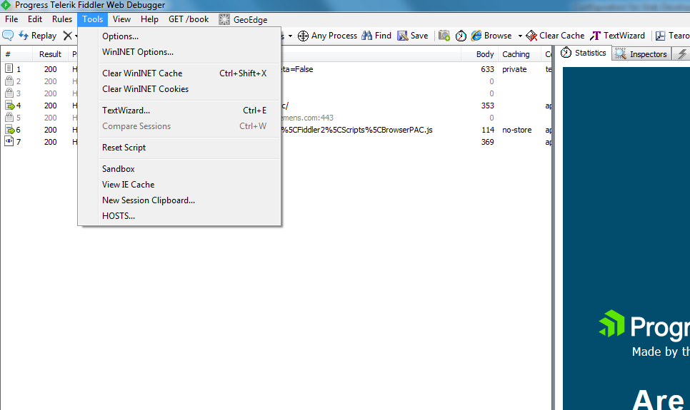

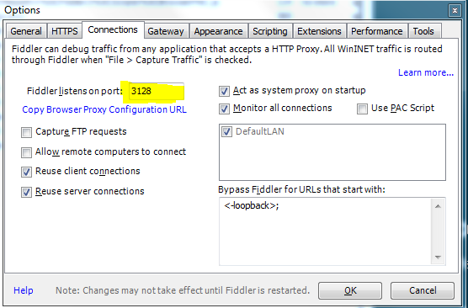

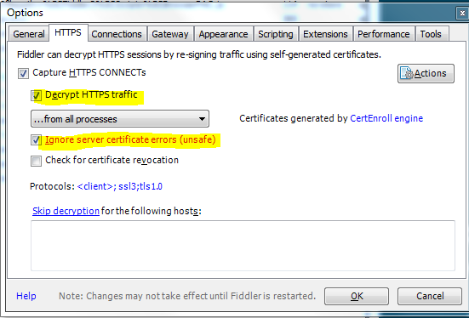

**Step 2:**

Go to following location on the machine

C:\Users*User Name*\

Open the **“.npmrc”** file in to notepad and paste following settings in to the file and save it.

proxy=http://127.0.0.1:3128/

https-proxy=http://127.0.0.1:3128/

strict-ssl=false

**Step 3:**

Add following setting to Editor:

"http.proxy": "http://127.0.0.1:3128",

"http.proxyStrictSSL": false

E.g. VSCode

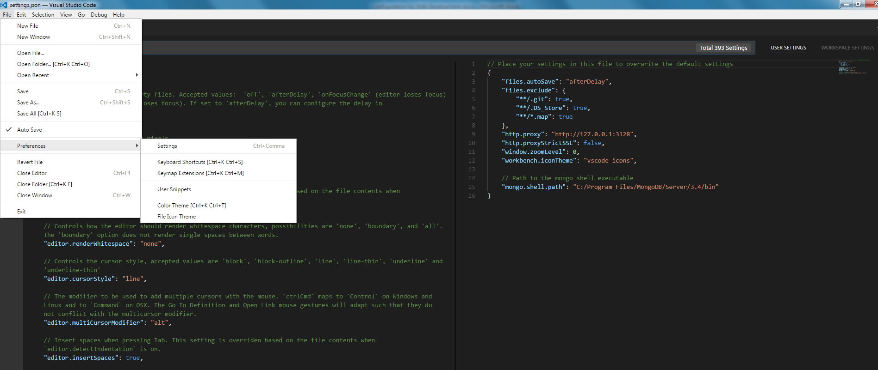

Make sure that while running command like “npm install” Fiddler is running.